SPECIAL

SCHOOL PICTURE DAY

Safety POLICIES & PROCEDURES

For the COVID-19 CRISIS
School Picture Day can be memorable and SAFE at the same time. Our new CONTACT – FREE process will allow Students, Faculty & Staff to be photographed while mitigating risks to personal health.
Parents still want to capture photo memories of their children, and you still need photos for Yearbooks & School Records. Plus, you’ll continue to receive the FUNDRAISING REBATES that come from photo sales.
Our exclusive program represents the best practices in safety during photography operations as prescribed by the Volume Imaging Professionals Association, a National advisory group serving our industry. Here’s what to expect from us.
- NO-TOUCH photography protocol with proper social distancing.
- NO printed forms to pass out. Parent contact handled by e-mail & text.
- NO hassle photo order process. Parents order online or by phone.
- NO physical collection of money or forms will be done on picture day.
- NO need to make change for currency thru the School Office.
- NO-TOUCH Class Composites or “Virtual Group” Photos.
- NO handling of portrait packages. We mail all portraits direct to home.
- NO WORRY customer service. We handle it all thru our local office.

We would welcome the opportunity to serve your school community with our special COVID-conscious, contact-free protocols to protect your Students, Faculty & Staff. Please contact us for more info or to schedule photo date(s). For your safety, we also offer ZOOM Consultations for contact-free visual communication.
INSERT YOUR STUDIO LOGO HERE
+ Your Name
+Contact Info
+ Phone, Email & Website.

Check Out Our Comprehensive CONTACT-FREE Photography Program
There’s much uncertainty today about plans for School re-openings for the upcoming semester. Every School District must make their own tough decisions regarding how and when they will operate this Fall, consistent with both the health and educational concerns of Students, Parents, Staff & Faculty.
We want you to know that we have the highest respect for the tremendous job you and your staff are doing in these trying times. We also know that your photography needs are probably not at the forefront of your planning at this time. However, at some point, you will realize that there are certain services typically provided by your School Photographer that you will require. These include Yearbook photos, ID cards, and images for your School Management software.
Parents of your Students would still appreciate the opportunity to purchase school pictures this year, provided they could obtain them as safely as possible. Families will continue to want these photos for gift-giving at Holiday time and to share with friends on social media.
Your school will also benefit financially from the sales of student portraits as you have done for years. These fundraising dollars could help support the purchase of personal protective equipment for students & staff or any other extraordinary expense you might have during this crisis.
The traditional ways that School Photography has been done over the years will not work in today’s COVID-conscious environment. No one wants to risk anyone’s safety by handling paper order forms, currency, and picture packages, and no one wants to be “posed” by direct contact working with a photographer that isn’t practicing social distancing.
All these factors and more have been considered in the development of our CONTACT-FREE photography protocol, which can provide the services your school needs, and the portrait memories that Parents will appreciate. These new processes will require some out-of-the-box thinking to execute, but we are prepared to do our part to make safety + school pictures a reality this year.
Feel free to reach out to us with any questions you have.

Scheduling for School Photos
There are several safe options for the process by which School photography can be conducted this year. We’ve instituted a comprehensive picture-day safety protocol based on best practices of CONTACT-FREE photography developed by Volume Imaging Professionals, our national trade association. We would be happy to design a custom program for your school based upon your own re-opening plans.
For In-School student attendees, we can accommodate alternative scheduling by offering multiple-day services instead of a single picture-day. This would accommodate A / B scheduling plans for reduced student enrollment on alternate days. We have adequate staffing to facilitate the doubling of days required to photograph everyone.
As social distancing and other precautions are mandated, the speed of the photography process will take slightly more time than usual. It’s important that we work with your School Secretary to adjust the picture day scheduling to allow this.
For 100% Remote Learners this Fall, we are offering an exclusive opportunity to participate in a special School portrait program. We can provide individual sessions on alternate dates and times, which will allow an extreme level of social distancing. This could be most convenient for working families.
Parents can book their own personal session times thru an online appointment system we’ll provide. This means not only that any waiting time is minimized, but Parents could bring all their children to be photographed at one time. They will likely be in and out in 5 minutes or less without having personal interaction with other Students and Parents.

We can be flexible concerning the actual location where we will set up to do photos. We will need slightly MORE space around each mobile studio to provide social distancing. In many cases, we can use the same space you’ve always allocated on picture day. However, if your average daily attendance will be lower this year (and thus less children to photograph in a single day), we may be able to operate within a smaller room or space at your school.
Venues for School Portraits

We would ask that the space provided for the photography to have at least two doors, one for entry and one for exit so that students can avoid close contact in and out. Larger schools with high enrollments may want to provide us with different rooms for each mobile studio set up to better facilitate social distancing.
Outdoor Portrait Option: We can also offer you the option of photographing OUTDOORS if that would prove to be more convenient to your school. Parents may appreciate this option to get something different in their portraits this year. To do this, however, we’ll need to have a contingency plan in case of inclement weather, either a pre-arranged “rain-out” date or the potential of moving inside.
Picture Day Communication to Parents
Picture Day announcements must be PAPER-LESS this year as Parents may be concerned about the possibility of virus spread through the handling of these materials. Our system eliminates the need for your school to distribute printed paper forms, pricelists, payment envelopes, etc. in advance of Picture Day as was previously done.
Our goal this year is to set up direct lines of digital communication with each Parent about Picture Day without having your school distribute paper notices. We want to get as many Parents as possible to pre-register their e-mail and text number with us BEFORE picture day. In doing so, they will receive not only money-saving discounts but also so that we can send them a secure private log-in to see their photos later online. This secure log-in will allow each Parent to see only their own children and no others.
To facilitate this, we ask that your school utilize any current method(s) you are now doing to communicate with Parents about Picture Day and the need to pre-register. Any or all of the following may be appropriate:
- Announcements on your School or District Website.
- E-mail or Text blasts to Parents.
- Outdoor or other electronic signage
- Announcements on School or PTA Facebook groups.
- Recorded voice announcements by auto-dialer phone system.
We will provide pre-written informational content for any of the above you can use to get the word out. We want to ensure that all Parents are pre-notified about picture day.
You may, at your option elect to provide us with Parent contact e-mail addresses and SMS / Test numbers and we’ll handle all communications with Parents. We do not require any proprietary student information; only the Parent contact method.
Privacy Notice: Rest assured that any such information provided us will be kept confidential and be used only for the purpose of School portrait marketing. This information will never be shared with or sold to other parties.
All of our communication with Parents will have our local office Customer Service phone and e-mail address so they can reach us, if necessary. Should any Parent call your school for any picture day information, please refer them directly to us. We understand how busy you are and don’t want your office to have to handle these questions.
Paper-Less Collection of Photo Orders
We can offer your school the option of a traditional PRE-PAY program, or a parent-preferred proof program where they can see their images before buying. For either program, all photo orders will be taken online or by phone to our office. The methods Parents may order by will be clearly explained in our Parent communications before picture day.
There will be NO paper order forms or paper proof sheets this year, and all purchases will be made by Debit or Credit card. If any Parent cannot make their payment in this fashion, they can contact our office, and we’ll make special accommodations for them.
Our safety goal in going paperless this year is to eliminate the possibility of contact transmission of the Coronavirus from the handling of forms or currency.
Our Preparation for Picture Day

We have educated our employees with comprehensive information regarding the best-practice prevention and occupational safety measures that are now required for a contact-free picture day.

Of course, we agree to follow all protocols concerning COVID safety instituted by your School, City, or State while working in your school.
Each member of our staff will have their temperature taken as well as being asked health screening questions each morning before starting to work. Employees exhibiting any respiratory symptoms or fever will not be allowed to work that day and until any health issue clears.
We will consult with you in advance about how we can enter and leave your building in a way that is neither disruptive to your school nor poses any risks related to social distancing.
We will bring with us hand sanitizer and surface disinfectant for use by our employees working in the mobile studios. We will also clean and sanitize our equipment and travel cases before entering your school.
We’ll also send you an information sheet in advance to share with Teachers and Staff to familiarize them with the changes in Picture Day protocols that are necessary this year. This may help ease any anxiety about the “new” Picture Day methods being employed this year.
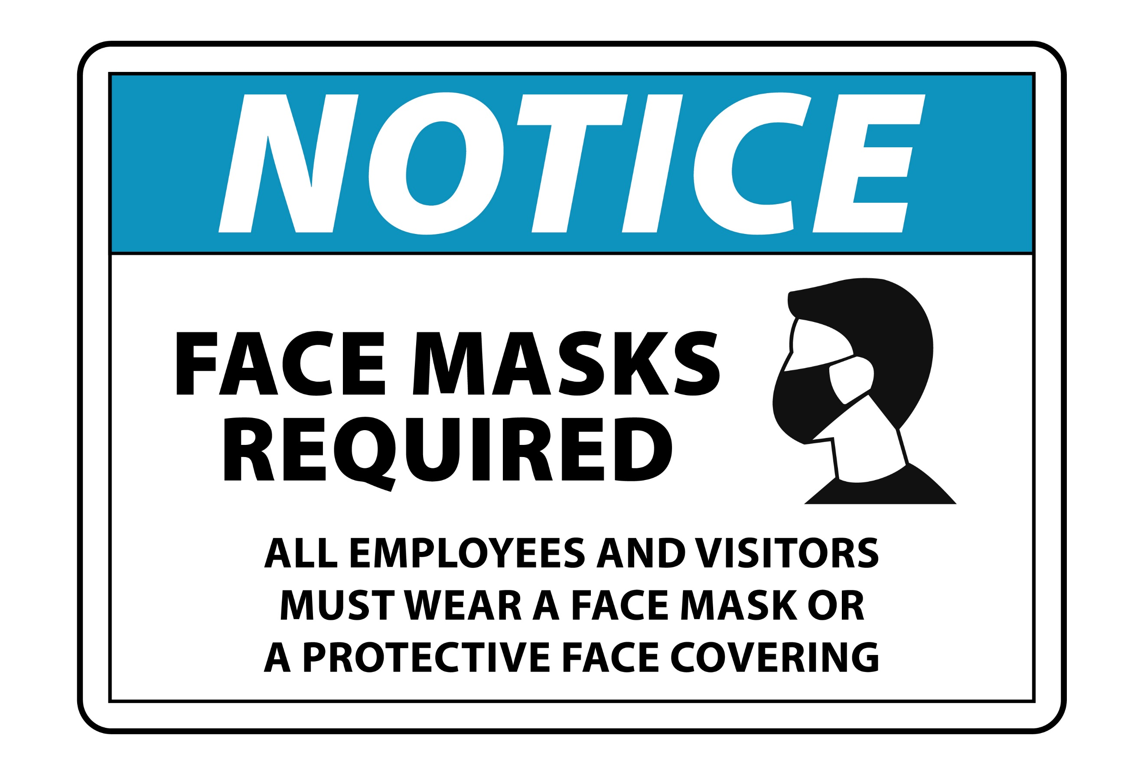

The Picture-Day Process for Contact-Free Photography.
While much of the photography process for picture day will remain the same as in previous years, there are some critical differences in place this time to support our contact-free program.
A. The schedule of classes to be photographed on picture day will be coordinated in advance with your School Secretary. This is to ensure that some additional time is allowed for correct social distancing and that we won’t have large groups of Students congregating at one time and place.
The line of children waiting to be photographed could easily extend into the hallway to facilitate social distancing. An alternative would be to photograph only half the class at one time. This could be Students with last names A thru M, shortly followed by the remaining students; N thru Z.
B. We will not be collecting payment envelopes or issuing Camera tickets to students before photography as has been done previously. This will eliminate the need for Teachers to handle the paperwork. Instead, we will use the Student data you provide us in advance to automate the method we use to identify each Student. We will verbally verify each Student’s name before photographing them instead of reading it from a form or envelope. We will ask each teacher to line-up the Students in alphabetical order for photography to speed up the identification process.
C. We will provide removable signage in the camera area to indicate proper spacing for each child waiting to be photographed. We will maintain a 6-foot interval between students and our staff at all times.
D. We will set up a free-standing mirror at each mobile studio so that Students can self-groom before photography. However, as this must be a contact-free picture day, we cannot ask our Staff or School volunteers to “groom” the children (fix hair or collars, etc.) before photography as we’ve previously done. We’ll convey this fact to Parents in advance through our picture day announcements. This may allow Parents to caution their children not to get their hair or clothing messy prior to getting photographed.
E. At your discretion and with your permission, we can also make available one-use disposable combs for students that need one. The table where these will be individually placed will be cleaned with disinfectant between each class.
F. Subjects will enter the mobile studio area from one side only, and exit from the other. Everyone able to will be photographed in a standing pose this year. It’s not practical time-wise to have to sterilize a posing stool or bench prior to each subject sitting down. We assure you that this procedure will not compromise the quality of the portraits we’ll be taking. All photos for school records will be cropped to the traditional head-and-shoulders look from the standing pose.
In fact, in our experience, we’ve found that the standing pose works better to minimize any visible wrinkling of blouses and shirts and eliminates shoulder slumping, thus providing a cleaner look for the portraits.
Anyone not willing or able to be photographed in a standing pose (i.e. persons with disabilities, etc) will be accommodated with seated posing.
Of course, we offer a 100% Guarantee of Satisfaction for our portrait work. If a parent is unhappy with the results of their child’s portrait, they may request a retake on the scheduled make-up day or get a full refund on printed portraits.
G. All our Staff will be wearing masks and gloves while onsite at your school. School staff and students should follow your own School policy regarding mask use before and after being photographed.
H. All photography to be done this year will be “touch-less.” Posing instruction will be delivered verbally or through hand direction. Our photographers will not approach subjects to manually position hands or legs.
Classroom Group Photos – Contact-Free Alternatives
It will be impossible to offer traditional classroom group photos this year due to the need for social distancing. However, we are offering a choice of two alternatives this year that we’re sure parents will appreciate.
Class Composite photos can be offered at the same price as the traditional class photos, but no additional classroom time is needed to set up and take a separate group photo. Other advantages of Composite photos over traditional groups are:
a) Allows those absent on the original picture day, or those requesting retakes to be included after the make-up day.
b) Often provides a better look for each child as this photo istaken individually, providing a better chance to get the best subject expression possible.

Insert Sample Class Composite Sample Here

Insert Sample VIRTUAL Class Photo Sample Here

This year we’re also offering “virtual” classroom group photos. These look much like traditional “stacked” classroom group photos except that they are digitally imaged from individual student photos thru a Photoshop-type process. We were the innovators of this process for the Sports Team market over ten years ago, and we’re experts at making these prints look “picture-perfect.”
Virtual Class Photos can also include any new student or retake images taken on the make-up day, making them more inclusive than traditional photos. There will be a slight upcharge in the selling price of Virtual group photos to offset the additional production labor required to produce them.
Both Composite and Virtual style group photos may require additional production time and may be delivered later than the individual portrait packages.
Delivery Time & “No Touch” Photo Package Distribution.
All portrait packages for individual students will be shipped directly to their home address. This will free your Teachers and Staff from the hassle of distributing them at school. Parents will appreciate that they will get their package intact and not found folded up in their child’s backpack.
All student portrait packages will ship to home in just 2-3 weeks after photos & orders are taken.
If you are offering a PROOF program, proofs will be posted online in 6-10 days after photos are taken. Proofs will be available online for a minimum of 45 days to accommodate those families that are paid only on the 1st or 15th of the month.
As additional production time may be required for Classroom Composite or Virtual Group photos, these may be delivered back to the school for distribution. If so, all photos will be individually packaged and labeled for easy distribution. For safety reasons, we recommend you wait at least 72 hours before opening the box they are delivered in. This delay will help mitigate any chance of any virus spread by contact thru shipping channels.
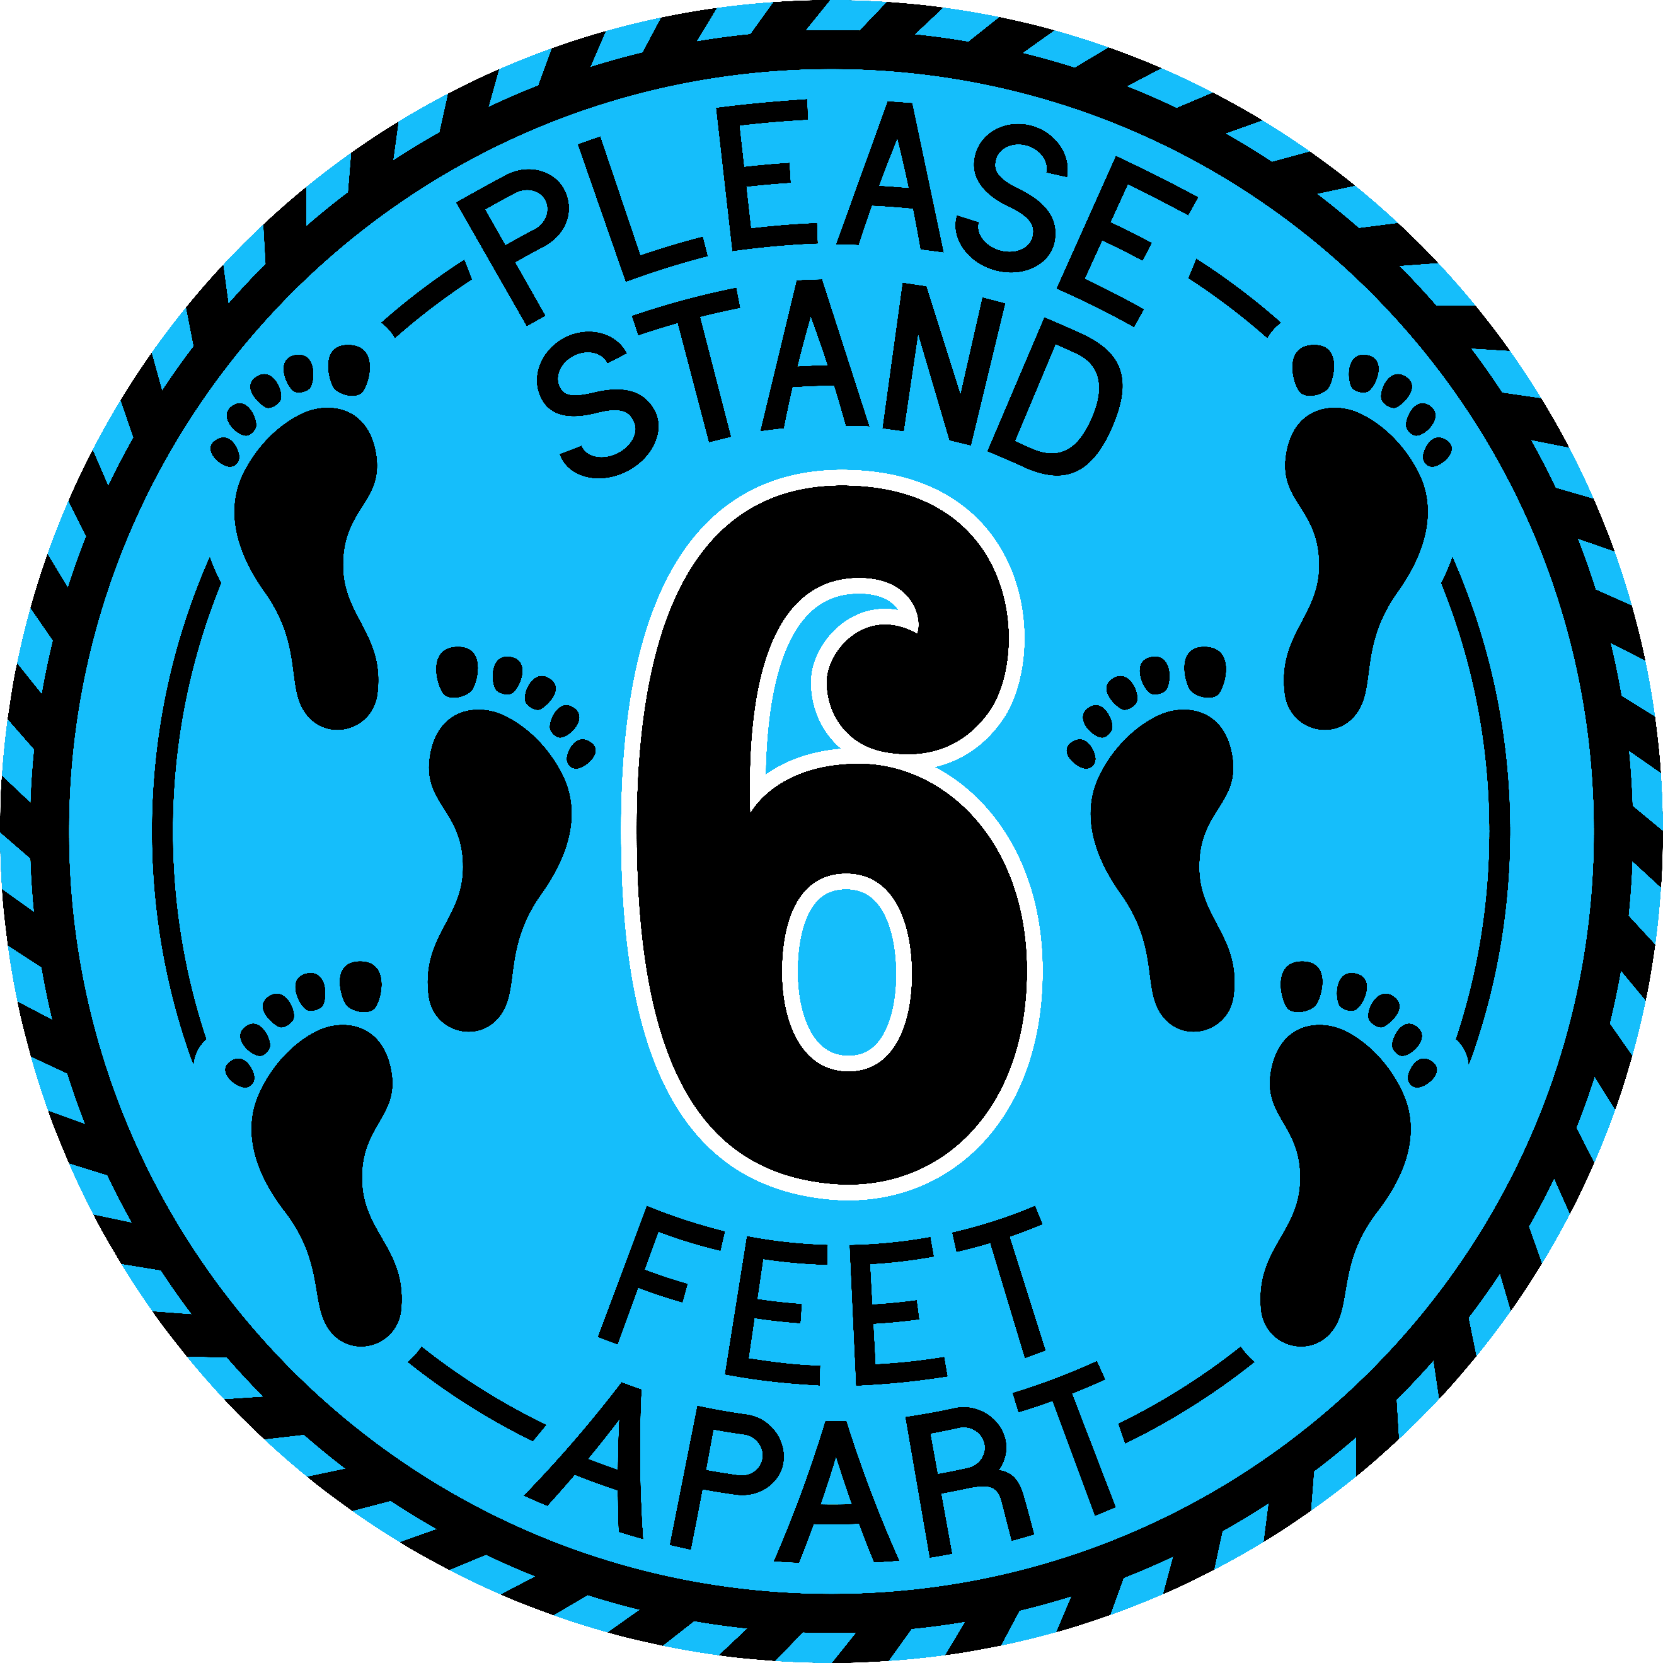

Delivery of School Service Products
Consult with us in advance if you have any special requests for the delivery of School Service products such as Yearbook Photo or School Image Software exports, printed ID cards or cumulative record photo strips, etc. We typically deliver these within 30 days of photography but can sometimes expedite this to meet your deadlines.
Again, if these are shipped or hand-delivered to your school, for safety, we recommend you wait at least 72 hours before opening the box they are delivered in.
COVID Precautions for other Programs
We’re equally conscious of the need for safe photography protocols for other programs offered at your school. You can rest assured that we’ve adopted best practices to permit these kinds of programs to go forward.
- Sports photography – Individual player and team photos.
- Group photos of all types – Large and small.
- Senior Portrait Programs.
- Graduations & Commencements.
- Family Portrait Fundraising programs.
INSERT YOUR STUDIO LOGO HERE
+ Your Name
+Contact Info
+ Phone, Email & Website.

